Intigriti – CTF Challenge: (2025-04)
CTF Submission: intigriti/HackDonalds Challenge/HackDonalds Challenge - Flag captured - INTIGRITI{XXE_1n_Ic3Cr34m_M4ch1n3s}
History of submission:
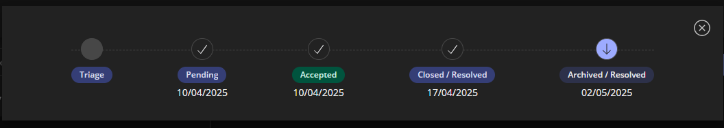
End point / vulnerable component: https://hackdonalds.intigriti.io/admin; https://hackdonalds.intigriti.io/api/parse-xml
Proof-of-concept / description:
- Initial recon: found next.js is being used which is vulnerable to authentication bypass (thru middleware bypass) (CVE-2025-29927)
- Captured https://hackdonalds.intigriti.io/admin request in BurpSuite with interception on
Added 'X-Middleware-Subrequest: middleware' header to bypass the middleware, thus bypassing authentication for admin (URL: )
- From admin page, navigated to https://hackdonalds.intigriti.io/Machine details page > 'XML Congfiguration Settings' section
- Captured XML requests and responses using BurpSuite and tested for XXE and path traversal. PoC payload used: (Successfully displayed the content of passwd file)
<!DOCTYPE data [ \n <!ELEMENT data ANY > \n <!ENTITY xxe SYSTEM
'file:///etc/passwd' >]> <Id>&data;</Id>
Note: header 'X-Middleware-Subrequest: middleware' was added to each request, as the page checks for authentication every time an update is made
- Brute forced XXE vulnerablitiy with various payloads to locate the flag and was able to locate the flag in 'file:///app/package.json'
- The flag is 'INTIGRITI{XXE_1n_Ic3Cr34m_M4ch1n3s}'

Impact:
- Authentication bypass allowed access to restricted Admin page without providing credentials, leaking sensitive information to any user.
- XXE and path traversal vulnerabilities give access to server files.
Recommended solution:
- Upgrade to latest version of Next.js
- Santise user inputs and restrict access for server files by whitelisting the files those needs access by the application
Screenshots:
